Basic Shapes
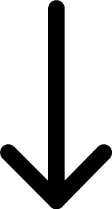 | 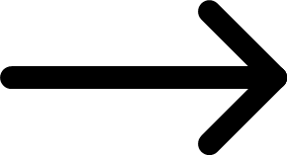 | 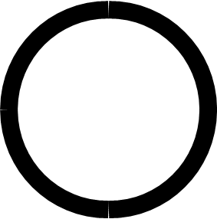 | 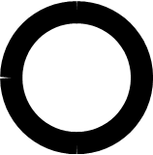 | 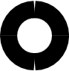
arrow-down | arrow-right | circle-large | circle-medium | circle-small
 | 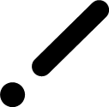 | 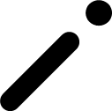 |  | 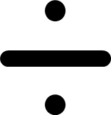
dot | half-line-dot - diagonal-line dot-left | half-line-dot - diagonal-line dot-right | half-line-dot - exclamation-point | half-line-dot - horizontal-line dot-above-below
 | 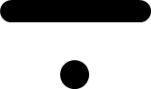 | 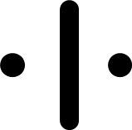 | 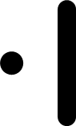 | 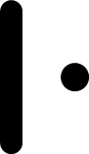
half-line-dot - horizontal-line dot-above | half-line-dot - horizontal-line dot-below | half-line-dot - vertical-line dot-left-right | half-line-dot - vertical-line dot-left | half-line-dot - vertical-line dot-right
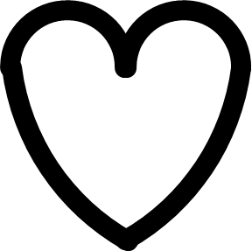 | 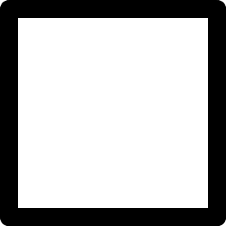 |  | 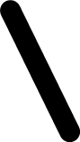 | 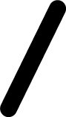
heart | square-full | line-vertical-half | line-angled1-half | line-angled2-half
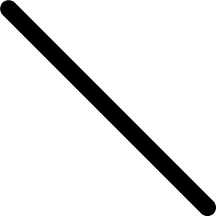 | 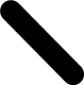 | 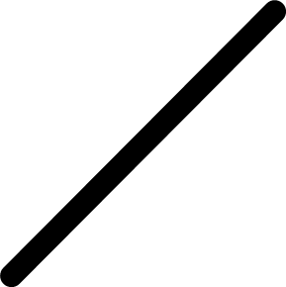 | 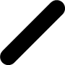
line-diagonal1-full | line-diagonal1-short | line-diagonal2-full | line-diagonal2-short | line-diagonal2-tiny
line-horizontal-full | line-horizontal-half | line-horizontal-quarter |  | line-vertical-full
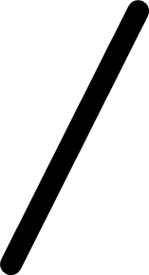 |  | 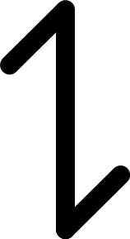 | 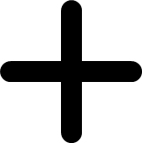 | 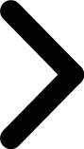
line-vertical-angle1 | line-vertical-angle2 | opposite indicator | plus-half | pointer-right
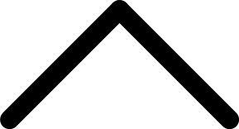 | 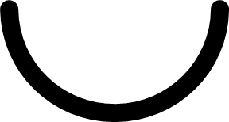 | 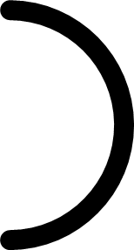 |  | 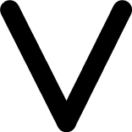
protection | semi-circle-down | semi-circle-right |  | v-down-half
 | 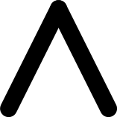 | 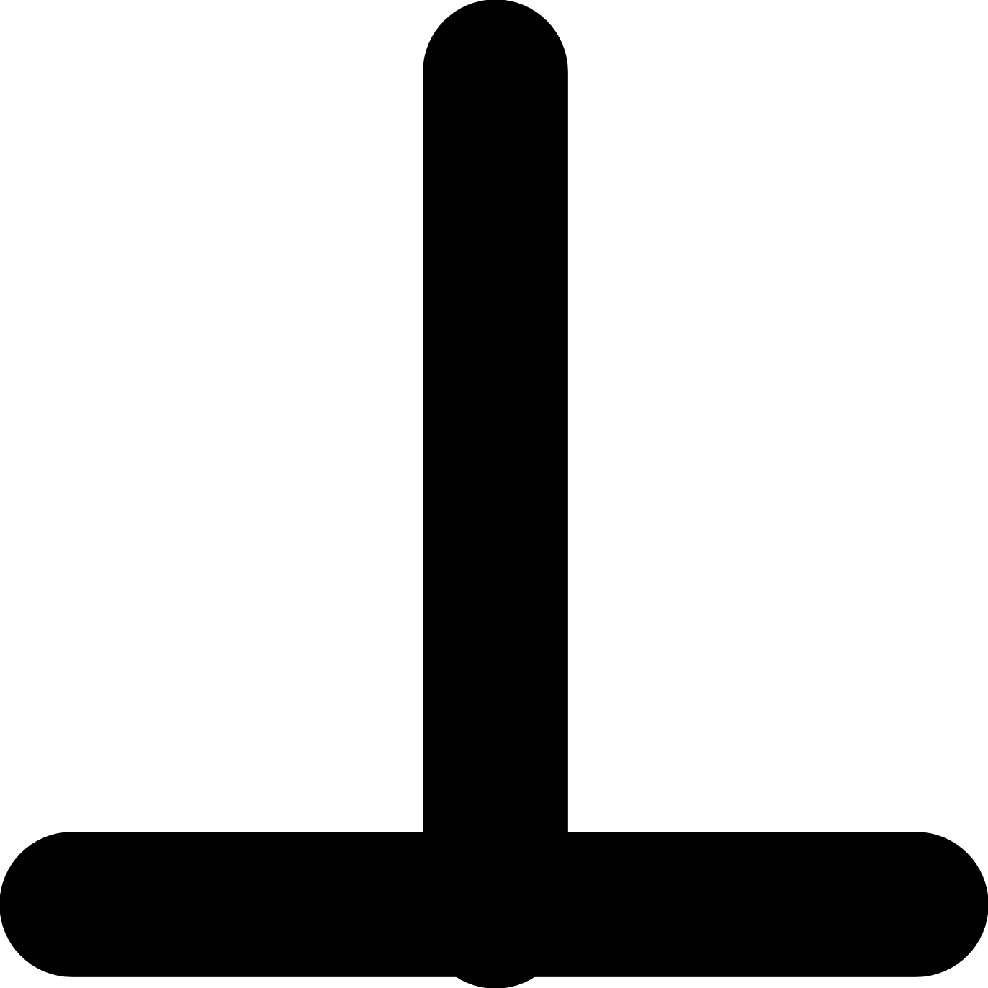 | 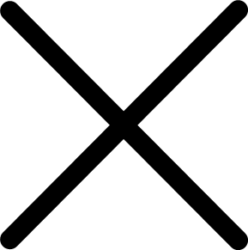 | 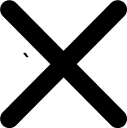
v-down-quarter | v-up-half | inverted-t | x-full | x-half
 | 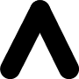 | 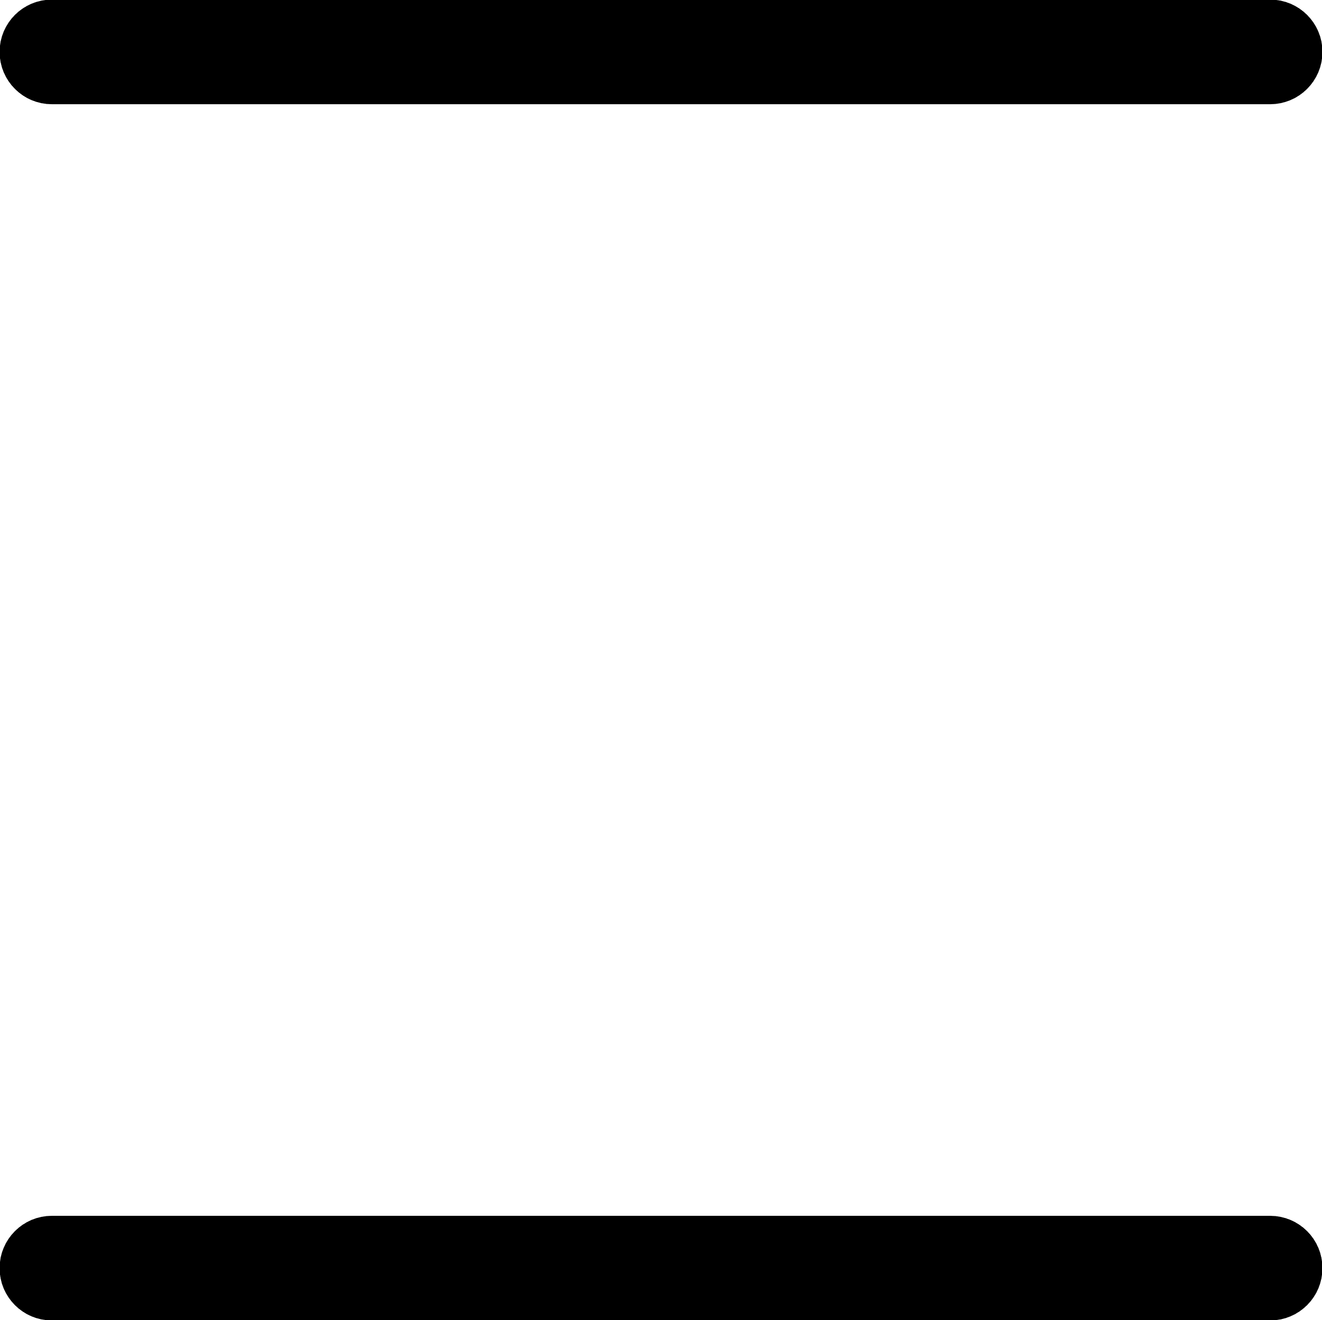 | 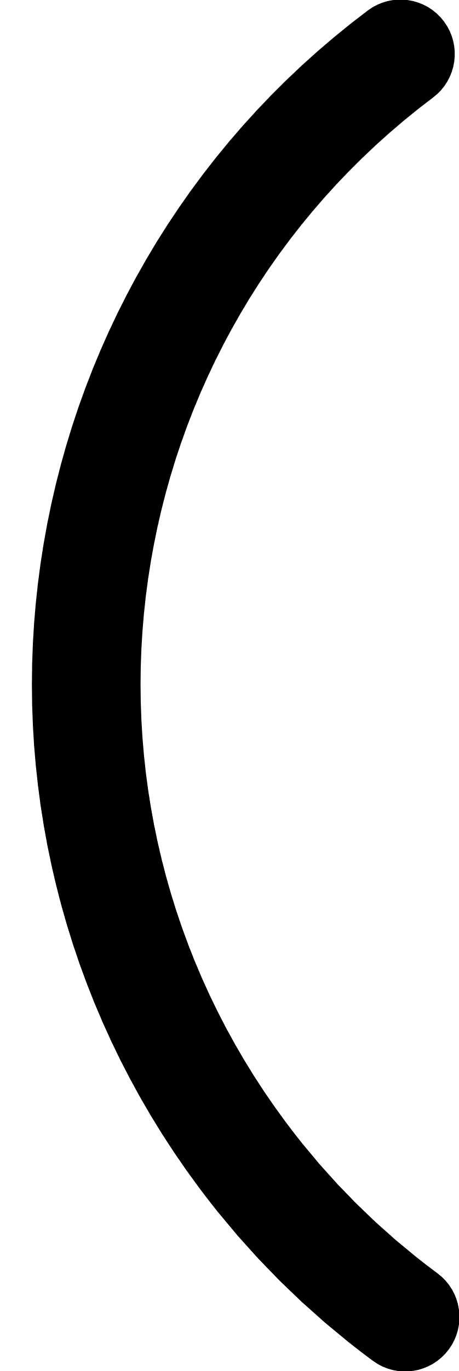 | 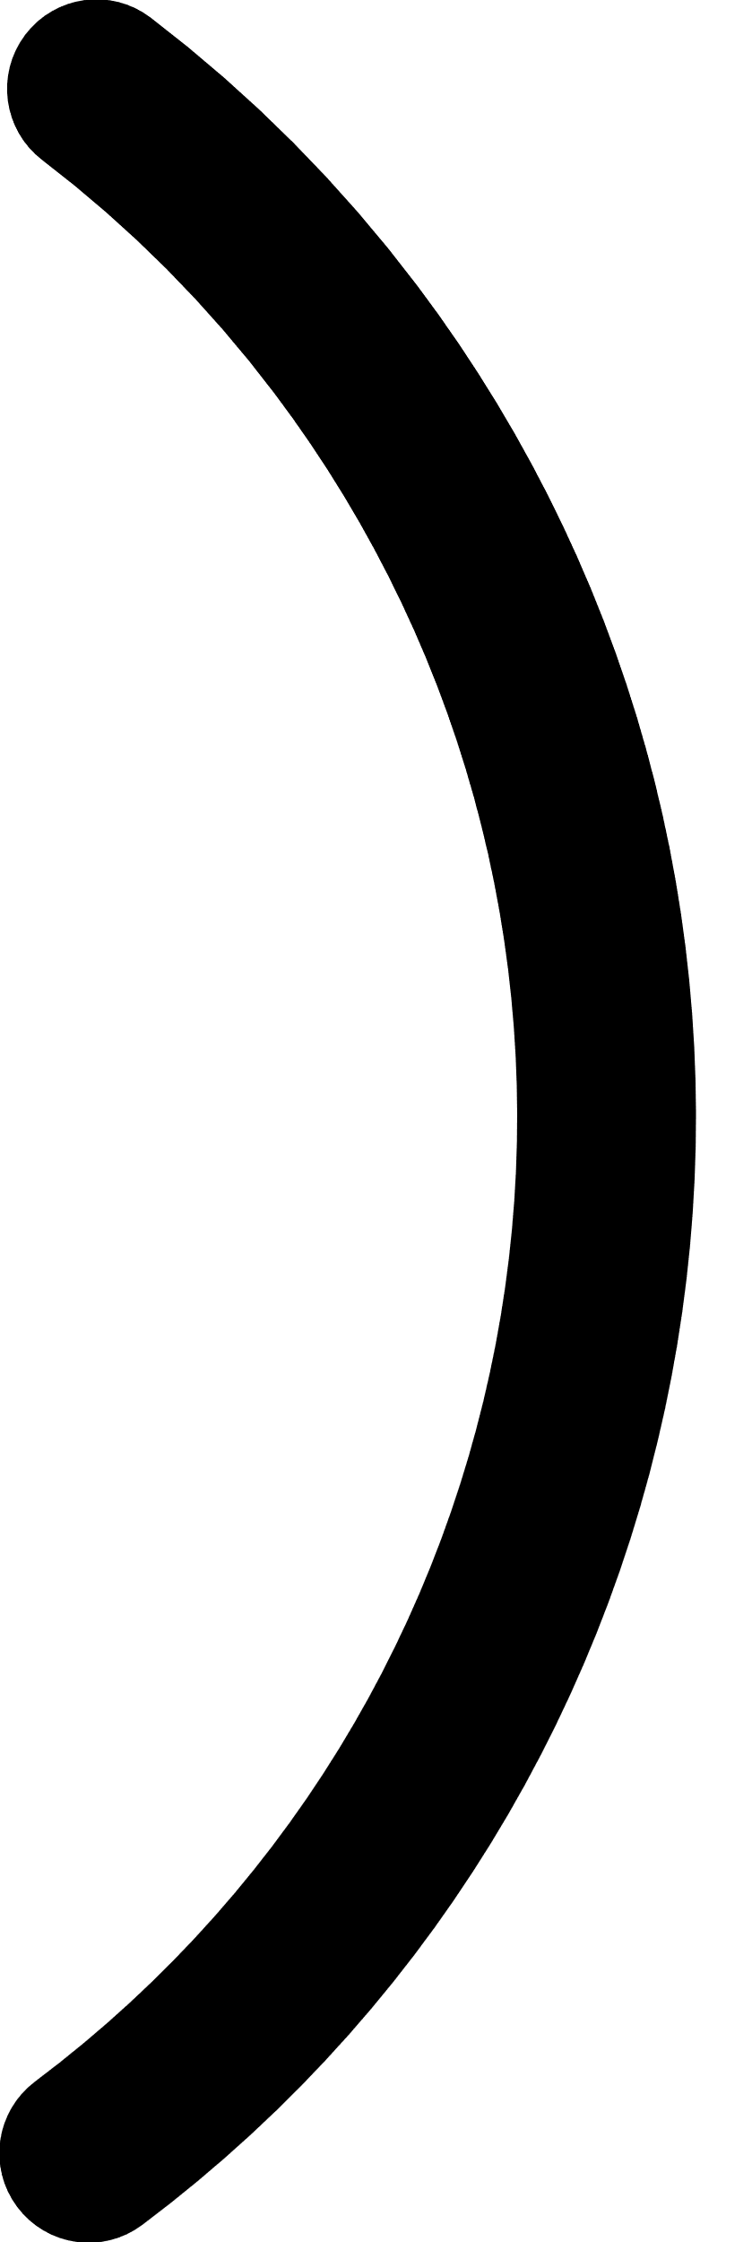
x-small | v-up-quarter | line-horizontal-full-pair-full | semi-circle-left-quarter-wide | semi-circle-right-quarter-wide
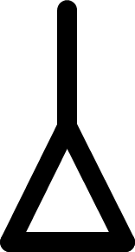 | 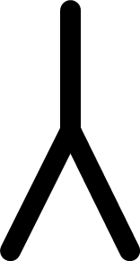
woman | man

